Threat Hunt Project – Living‑Off‑the‑Land (LOTL) Attack Detection
Part A: Red Team Simulation (High‑Level, Safe, Professional)
Objective
Simulate a realistic attacker scenario using native Windows tools to demonstrate how adversaries can:
• Execute malicious activity without dropping traditional malware
• Abuse PowerShell for encoded or obfuscated command execution
• Perform reconnaissance or lateral movement using built‑in utilities
This project focuses on detecting PowerShell abuse, encoded command execution, and fileless techniques through host‑based logging and event analysis.

Hypothesis
“An attacker may be using PowerShell or other native Windows utilities to execute payloads or perform malicious actions without writing files to disk.”
This hypothesis directs the hunt toward:
• Script block logging
• Module logging
• Process creation events
• Network connection events
• Indicators of encoded or suspicious PowerShell usage

Data Sources
To validate the hypothesis, the following log sources were used:
• Windows Security Logs – process creation, logon activity
• PowerShell Operational Logs – script block execution, module usage
• Sysmon Event ID 1 – detailed process creation
• Sysmon Event ID 3 – network connections
These sources provide visibility into how PowerShell is invoked, what modules are loaded, and whether suspicious child processes or outbound connections occur. This configuration ensures that any malicious or suspicious PowerShell activity performed during the simulation is fully observable in the logs.
The simulated attacker activity includes:
• Executing PowerShell commands designed to mimic fileless techniques
• Triggering encoded or obfuscated command execution
• Generating process creation events consistent with lateral movement or reconnaissance
• Producing network connection events that can be correlated with suspicious behavior
No harmful commands or payloads were used; the focus is on generating behavioral telemetry that mirrors common attacker tradecraft.

Part 1:
turn on windows logging.
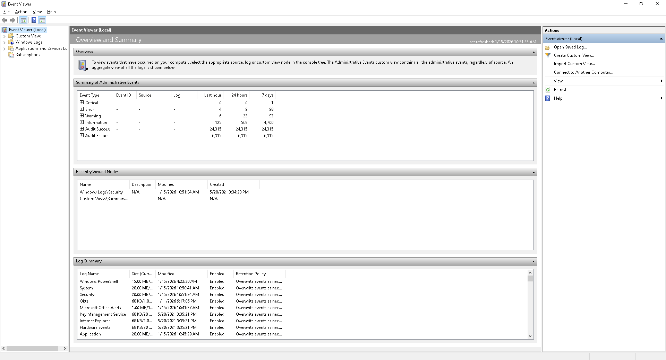

Turn on PowerShell logging:
*Most just do what the instructions state however you need this to record and track the attacker essentially, you’re making the attack.
On your keyboard you're going to press windows key plus press R
When your run box comes up essentially what you're going to type is lowercase GPEDIT dot MSC
press enters
this will pull up your local group policy editor.
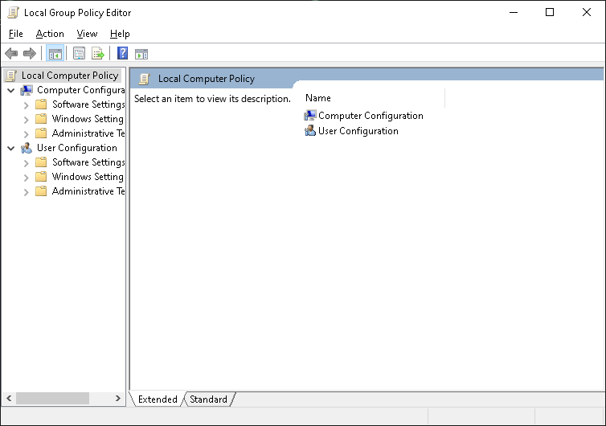

Part 2 understanding the folders:
on the left side clicking is in this exact order:
one click the arrow next to computer configurations.
Two click the arrow next to the administrative template.
Click the arrow next to the window components.
Click windows PowerShell.

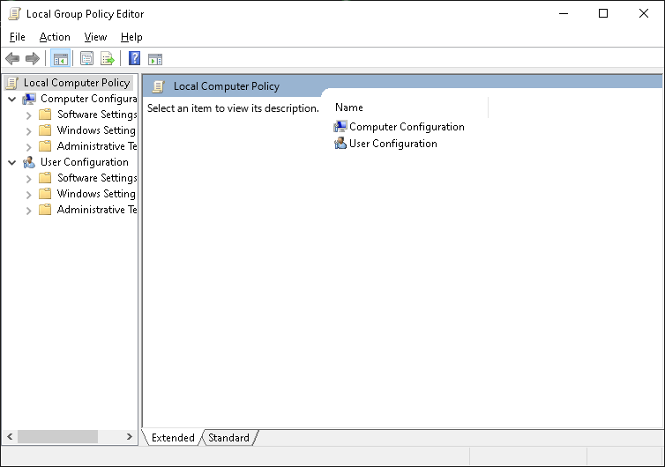

Part 3 enable script block logging
on the right side double click and turn on the PowerShell script block login
a window opens.
One you're going to click enable
two you're going to click OK this records every PowerShell command even hidden ones kind of like a self key logger.
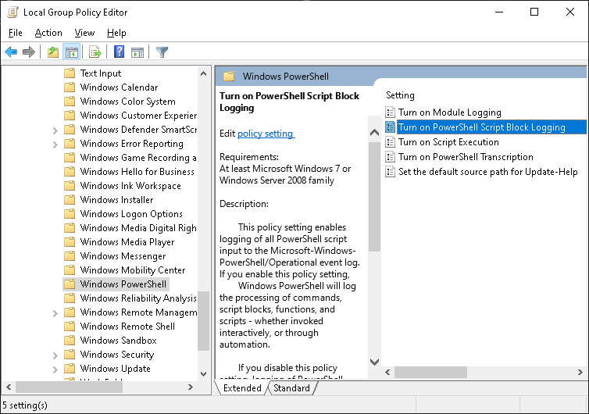
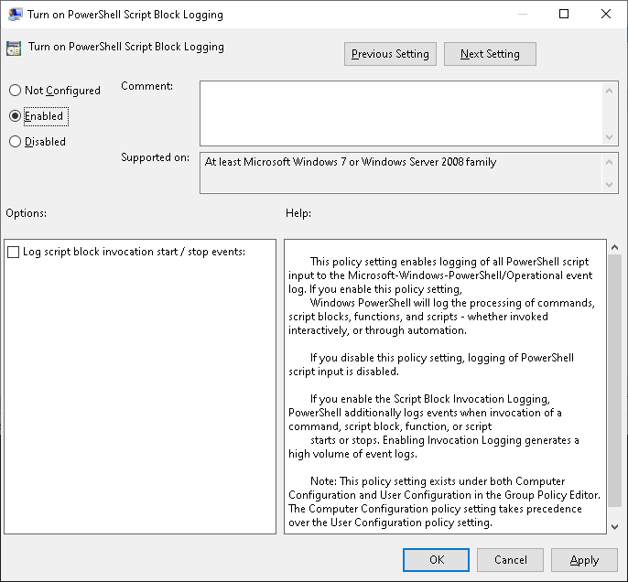

Part 4 enable module logging
turn on module logging
click enable
click OK
*this records what PowerShell features were used good trick for those who are trying to get in digital forensics if you have a compromised computer you can use this also to get artifacts and you can also get a chronological path of where the attacker Has been.
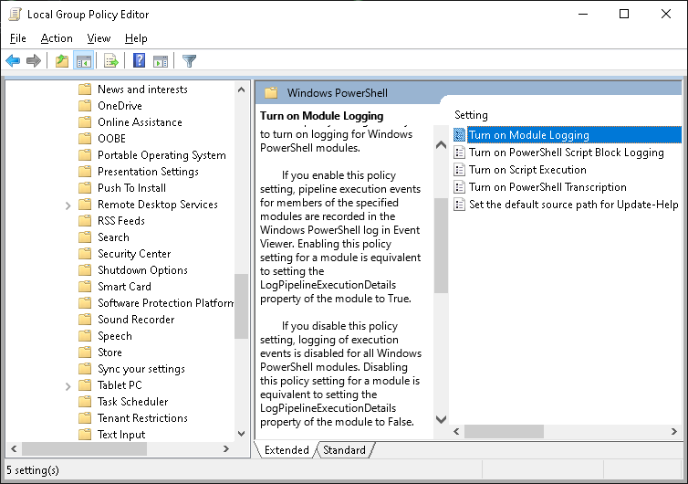
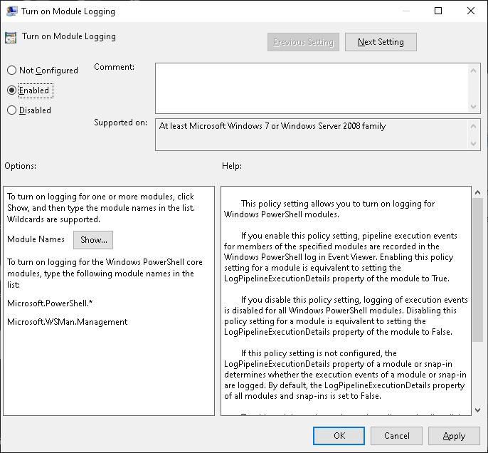

Part 5 apply the changes
hold windows and press R
type gpupdate /Force
press enter
stand by what you're waiting for is user policy update complete successfully
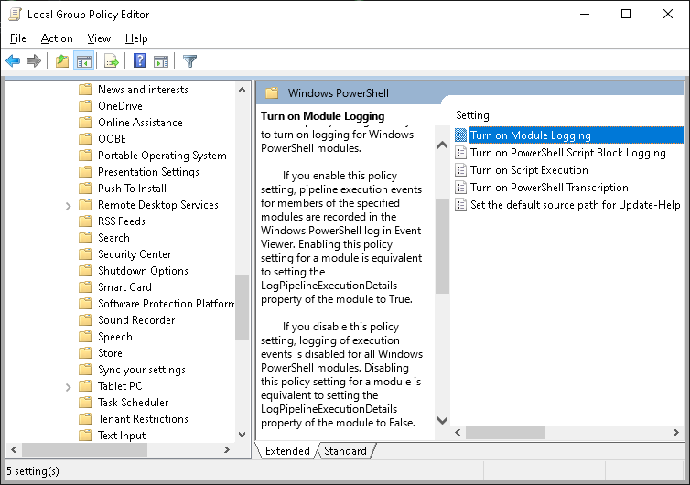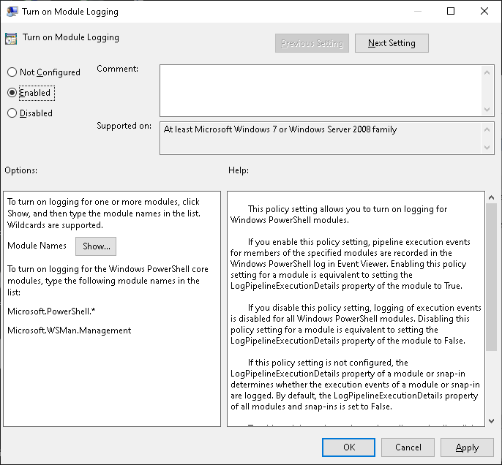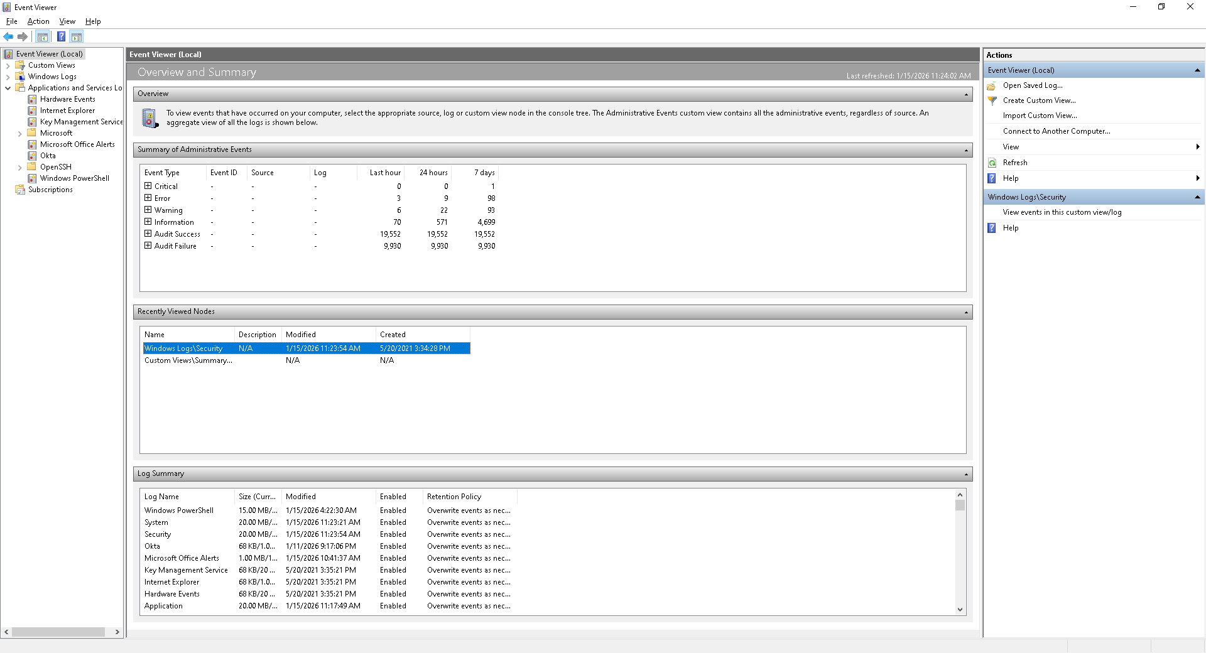
If you look inside the view event viewer you will be able to see that there was logging there was movement and that everything is verified that has been enabled activated you have now set yourself up as the attacker and why does this matter this is because hackers typically use PowerShell and they use it a lot especially on windows a lot of people think it's they're using secret scripts and when people first start you need to be honest with them they're using basic PowerShell scripts they're using basic window scripts when you start getting into Linux you start getting into more sophisticated why because Linux is open source and has more flexibility of syntax.
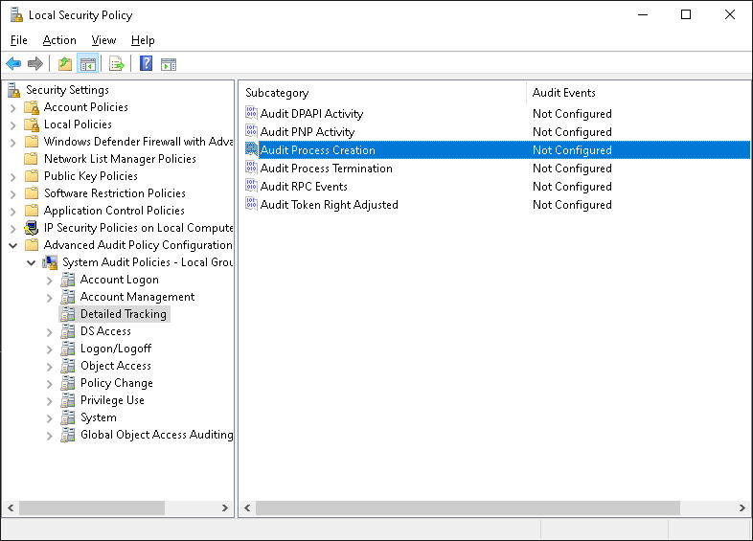

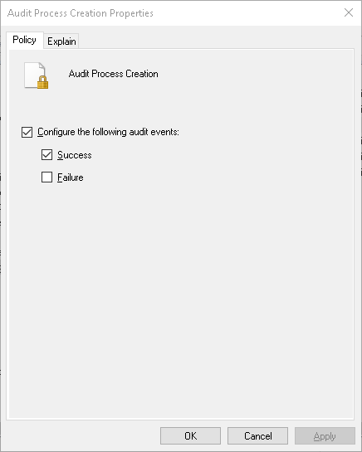
Purpose of This Setup
This red‑team simulation serves two goals:
1. Demonstrate how real attackers abuse built‑in Windows tools
LOTL techniques are widely used because they blend into normal system activity and bypass traditional antivirus.
2. Show that effective threat hunting can be performed with native tools
By using Windows Event Viewer and Sysmon, this project highlights that meaningful detection and analysis can be done without enterprise SIEM platforms.
RED TEAM perspective.
MITRE ATT&CK Mapping (Red Team Perspective)
Living‑off‑the‑Land PowerShell Abuse Simulation
This mapping reflects the behaviors your simulated attacker demonstrated, aligned to MITRE ATT&CK tactics and techniques.

TA0001 – Initial Access
T1078 – Valid Accounts
Your simulation assumes the attacker already has access to the system and is using legitimate credentials or an existing session.
This is common in LOTL attacks where adversaries avoid dropping malware.

TA0002 – Execution
T1059.001 – PowerShell
Core technique of your project.
The attacker uses PowerShell to execute commands, run encoded payloads, or perform reconnaissance.
T1059 – Command and Scripting Interpreter
PowerShell is a native interpreter abused for execution without dropping binaries.

TA0003 – Persistence
(If your simulation included repeated execution or scheduled tasks, this applies. If not, you can omit.)
T1053 – Scheduled Task/Job (Optional)
Attackers often use scheduled tasks to maintain access using native tools.

TA0004 – Privilege Escalation
(Only include if your simulation involved privilege changes.)
T1548 – Abuse Elevation Control Mechanisms (Optional)
PowerShell often runs with elevated privileges if the user session allows it.

TA0005 – Defense Evasion
T1027 – Obfuscated/Encrypted Files or Information
Your encoded PowerShell command simulation fits this perfectly.
T1055 – Process Injection (Optional)
If your simulation mimicked fileless execution patterns.
T1562.004 – Disable or Modify System Logging (Optional)
Attackers often attempt to evade detection by modifying PowerShell logging — your project enables logging, but the mapping acknowledges the behavior.

TA0006 – Credential Access
(Include only if your simulation touched credential material.)
T1003 – OS Credential Dumping (Optional)
PowerShell is frequently used for credential harvesting.

TA0007 – Discovery
T1082 – System Information Discovery
Attackers often query system details using PowerShell.
T1083 – File and Directory Discovery
PowerShell commands can enumerate directories and files.
T1049 – System Network Connections Discovery
Sysmon Event ID 3 visibility aligns with this behavior.
T1018 – Remote System Discovery
PowerShell is commonly used to probe other hosts.

TA0008 – Lateral Movement
T1021 – Remote Services (Optional)
PowerShell Remoting, WMI, or SMB can be used for lateral movement.

TA0010 – Exfiltration
T1041 – Exfiltration Over Command-and-Control Channel (Optional)
If your simulation includes outbound connections or data staging.

TA0011 – Command and Control
T1071.001 – Web Protocols (Optional)
PowerShell often communicates over HTTP/HTTPS to blend in.
Red Team Simulation Overview
PowerShell logging was enabled to ensure full visibility into script execution:
• Script Block Logging – captures full command content, including hidden or obfuscated commands
• Module Logging – records which PowerShell modules were invoked
• Process Creation Logging – identifies parent/child process relationships
This configuration ensures that any malicious or suspicious PowerShell activity performed during the simulation is fully observable in the logs.
The simulated attacker activity included:
• Executing PowerShell commands designed to mimic fileless techniques
• Triggering encoded or obfuscated command execution
• Generating process creation events consistent with reconnaissance or lateral movement
• Producing network connection events that can be correlated with suspicious behavior
No harmful commands or payloads were used; the focus was on generating behavioral telemetry that mirrors common attacker tradecraft.
MITRE ATT&CK Mapping (Red Team Perspective)
Living‑off‑the‑Land PowerShell Abuse Simulation
TA0001 – Initial Access
T1078 – Valid Accounts
Assumes attacker already has access and is using legitimate credentials.
TA0002 – Execution
T1059.001 – PowerShell
T1059 – Command and Scripting Interpreter
TA0003 – Persistence (Optional)
T1053 – Scheduled Task/Job
TA0004 – Privilege Escalation (Optional)
T1548 – Abuse Elevation Control Mechanisms
TA0005 – Defense Evasion
T1027 – Obfuscated/Encrypted Files or Information
T1055 – Process Injection (Optional)
T1562.004 – Modify System Logging (Optional)
TA0006 – Credential Access (Optional)
T1003 – OS Credential Dumping
TA0007 – Discovery
T1082 – System Information Discovery
T1083 – File and Directory Discovery
T1049 – System Network Connections Discovery
T1018 – Remote System Discovery
TA0008 – Lateral Movement (Optional)
T1021 – Remote Services
TA0010 – Exfiltration (Optional)
T1041 – Exfiltration Over C2 Channel
TA0011 – Command and Control
T1071.001 – Web Protocols
Simulated Command‑and‑Control (C2) Beaconing
A continuous outbound network request was generated to simulate malware “calling home.”
This activity produced:
• A persistent PowerShell process
• Repeated outbound network connections
• Observable Sysmon Event ID 3 entries
This telemetry is used in the Blue Team investigation to identify anomalous network set up DETECT Command -and -Control (C2)
Open power shell
Ping 1.1.1.1 -t
*Let this run 60 Sec. This simulates malware calling home. 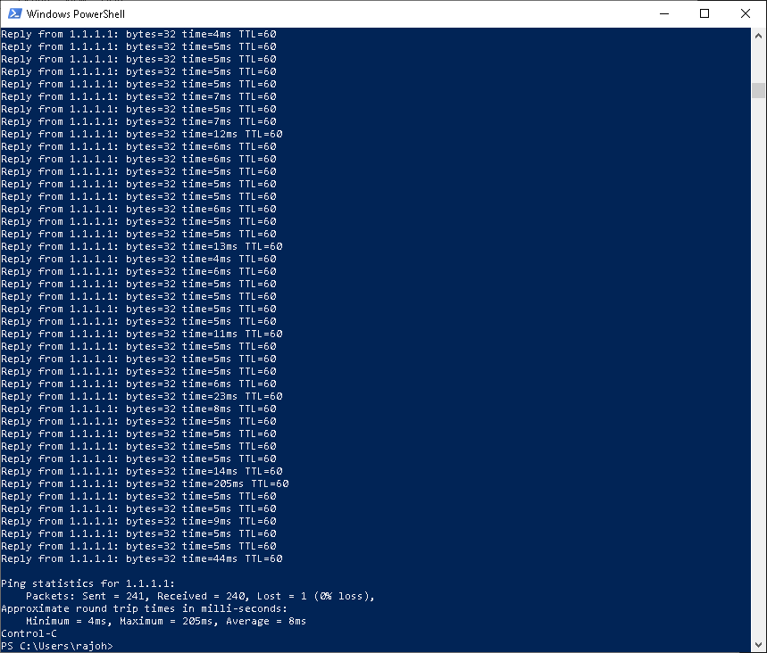

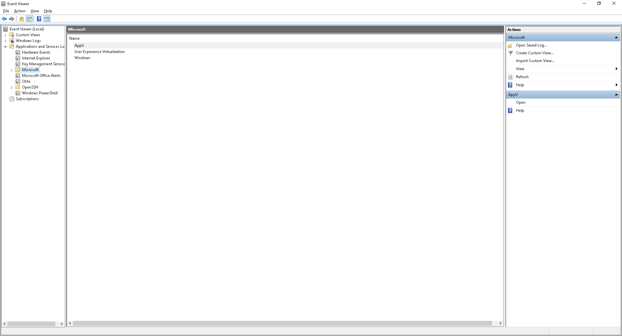
Now we'll go into event Finder and essentially we're going to Sysmon and as we'll see we'll have a creation process that was created we'll also see termination of disabling of logging of logging monitoring also sometimes if you're in CDC just like I added a key logger effect you should be able to see that as a misconfiguration on the CCTC side that will also be a tall tale normally these on a normal end user or endpoint this is not usually configured to be enabled this is also IOC that'll let you indicate that something deeper is going on.

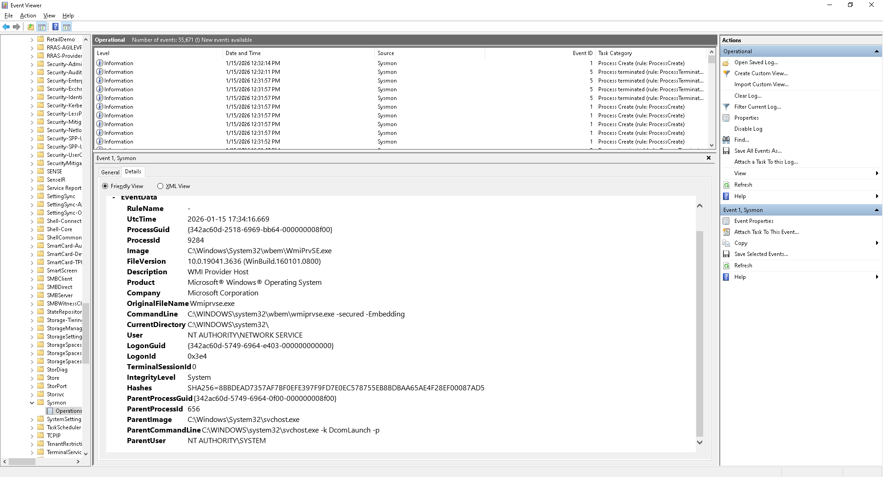

And here is where we find the actual logs in event viewer that'll let you know that this was compromised and that the breach was the breach had happened or the attempt or CC of a breach most people overlook this because there's no added incentives meaning there's no tools to use or anything else when normally all it takes is exploration of the OS and or of the system in which was breached to begin with um a lot of people don't do that this is a misstep that I've noticed a lot of people that I've talked to who are young and sock they really don't understand this um how I came to understand it was a lot of reading um a lot of sitting back and watching discords of people doing things in labs and I've seen a few labs where people have forgotten this stuff not everything requires a tool it only requires what's between your ears which is your brain hope this helps and like I said for the next 30 days I'll be doing 1 project a day and uploading these links on my profile and also My Portfolio thank you very much.

